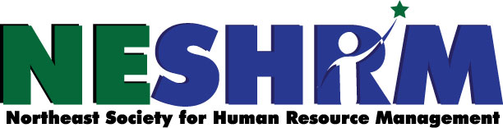
26th Annual Human Resource Conference
Wednesday, September 21st, 2022
University of Maine at Presque Isle
181 Main Street Presque Isle, Maine

8:00AM - 8:30AM Registration

8:30AM – 8:45AM Welcome by NESHRM President Danielle Cyr

8:45AM - 10:15AM “Disability Inclusion as a Resource to Workforce Challenges”
Chris Hynes & Susan Gatti
Maine Medical Center Department of Vocational Rehab

10:15AM – 10:30AM 15 Minute Break Sponsored by Manpower

10:30AM – 12:00PM “Diversity, Equity & Inclusion in Hiring”
Anne-Marie L. Storey, Esq.
Rudman & Winchell

12:00PM – 1:00PM Lunch and Visit Vendors

1:00PM – 2:00PM “In Our Own Voice”
National Alliance on Mental Illness

2:00PM – 2:15PM 15 Minute Break Sponsored by TEMPO Employment Services

2:15PM – 3:30PM “Employee Assistance Program Benefits”
Karen Ryla

RETURN REGISTRATION WITH NON-REFUNDABLE PAYMENT BY SEPT. 7TH
Mail to NESHRM, PO Box 1572, Presque Isle, ME 04769

REGISTRATION FORM $99/person OR $95/person for Multiple Attendees
ORGANIZATION:
MAILING ADDRESS:
PHONE:
NAME OF ATTENDEE(s):
EMAIL ADDRESS(s):
TO PAY ONLINE VISIT neshrm.shrm.org & EMAIL THIS REGISTRATION FORM TO:
julie.doody@aroostookaging.org

